2.8.2026

Spring boot framework for java backend development
@RestController: handles http requests (API)
@Service: problem solving (business logic)
@Repository: CRUD operations on database
Maven project manager (no need to worry about it)

3.8.2026
Spring Boot dev tools used to automatically restart app after changing compiled code
You add it as a dependency in pom.xml
Enable settings in IntelliJ

Spring Boot Actuators give endpoints (URLs) that show “health” of the program, so that the developer makes sure app is working properly
Add it as a dependency in pom.xml
/actuator/health: shows health of app
/actuator/metrics: shows number of requests
/actuator/info: shows info configured by developer

Cant make all actuator endpoints public because they can expose sensitive info
Endpoints access:
management.endpoints.web.exposure.include= //endpoints to expose//
management.{{ endpoint }}.env.enabled= //true or false//

Spring Boot Security secure endpoints
Add dependency to pom.xml
Whenever you try to access endpoint, you will be asked to enter a username and a password
After running app, developer will get a password to use to access endpoints (username = user)

Running Spring Boot app from cmd
cd /d “folder path”
mvnw package
ctrl C to close app

Injection of Application Properties (@Value) used to inject custom application properties into java app

4.8.2026
Inversion of Control instead of me creating objects my application needs, Spring does it for me
Uses Dependency Injection (object/function receives objects it needs instead of creating them internally)
- Constructor injection (use by default): object
- Setter injection (use if have optional dependencies): function
- Field injection (not recommended)

@Qualifier(“”) -> used to choose which Spring Bean to autowire
@Primary -> makes one Spring Bean primary to choose by default if no @Qualifier is set

Bean Scopes:
Singleton (single instance of the bean only)
Prototype (instance for each time it’s required)
Request (scoped to an http request)
Session (scoped to an http session)

@Bean used to make a 3rd party class, which does not have the @Component, to be a bean

Hibernate framework for communication between Java and database
It does ORM (object-relational mapping): convert Java objects into a database
Class table
Object row
Java field column

JPA (Java Persistence API) set of rules (interface & annotations) implemented by Hibernate (and many other frameworks) to communicate with a database
Entity Class: java class mapped to a database table
Put before class: @Entity
@Table(name = “table-name”)

Map fields (java variables) to database columns):
Put before declaration: @Column(name= “column-name”)
@Id -> shows that field is primary key
@GeneratedValue -> tells app that the value of this field will be automatically generated
@GeneratedValue(strategy=GenerationType.IDENTITY) -> means that the value of this field will be generated by the database

Data Access Object (DAO) class that allows app to communicate with a database
It uses the @Repository
It implements a DAO interface class
It has CRUD operations: save() -> create
findById() -> gets one record
findAll() -> gets all records
update() -> update existing data
deleteById() -> delete a record
- Add method to DOA interface
- Add method to DOA implementation class
- Update the main app

6.8.2026
REST API
Post Create ; GetRead ; Put Update ; Delete Delete
Use Postman to test the API instead of using the front-end
Jackson converts between JSON and Java POJO (plain old java object)
Setter methods -> JSON to Java POJO
Getter methods -> Java POJO to JSON

API Design Process:
- Review API requirements (given from supervisor/leader)
- Identify main resource / entity (root url /entity)
- Use HTTP methods to assign actions on resource
POST create new entity /api/entity
GET read list of entities or single entity /api/entity /api/entity/{entity}
PUT update an entity /api/entity
DELETE delete an entity /api/entity

EntityManager: object used to manage an entity (object saved in database)
entityManager.find(Entity.class , ID ) -> return an entity based on its ID
entityManager.merge ( object ) -> updates entity if exists or create new entity
entityManager.remove (object) -> remove object from db
TypedQuery<entity> theQuery = entityManager.createQuery (“jpql statement “ , entity.class)

9.8.2026
Problem: you would need to do all DAO work and implementation for every single entity .
Solution => JpaRepository

JpaRepository < Entity , Pk’s type >
CRUD methods already created
findById()
findAll()
save()
deleteById()

Spring Data Rest: instead of writing code for the RESTController myself, spring does it for me
Just add dependency in pom.xml file
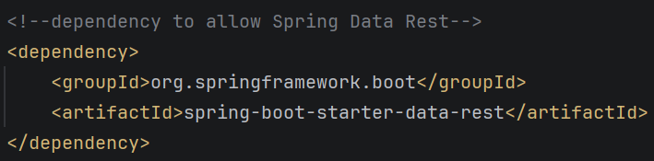
You will automatically have the GET, POST, PUT, DELETE endpoints ready
Delete the rest controller and service files
Only need the entity, JPA repository, and the pom.xml dependency

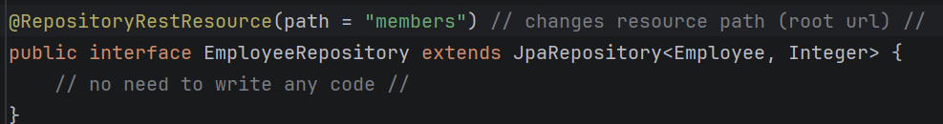
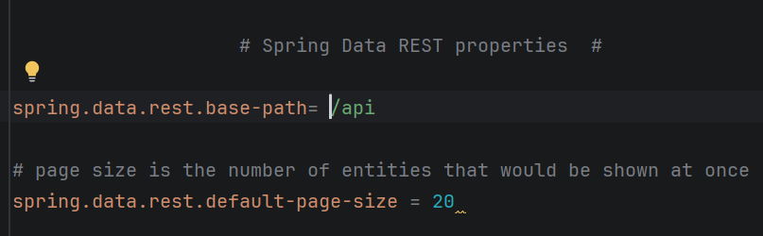

Sorting => /api/users?sort=lastName,asc

OpenAPI and Swagger

OpenAPI => standard specification (documentation) for your REST API
Swagger => gives you a webpage to test your API (instead of postman)

Add dependency in pom.xml
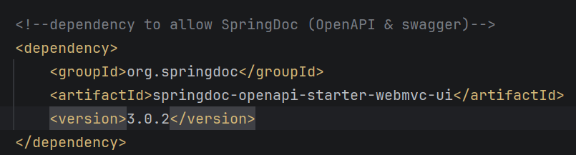

Configurations in application.properties
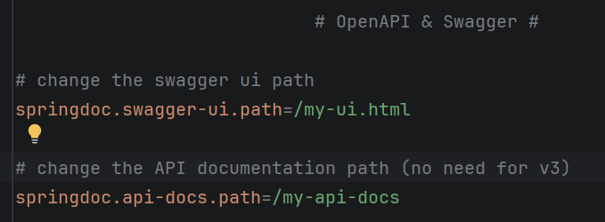

REST API Security

Add dependency to pom.xml
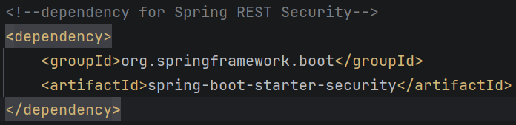
This will require a username (“user”) and password (given after running app) in order to view webpage

To set my own username & password:
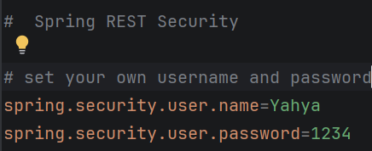

To add users who are authorized :
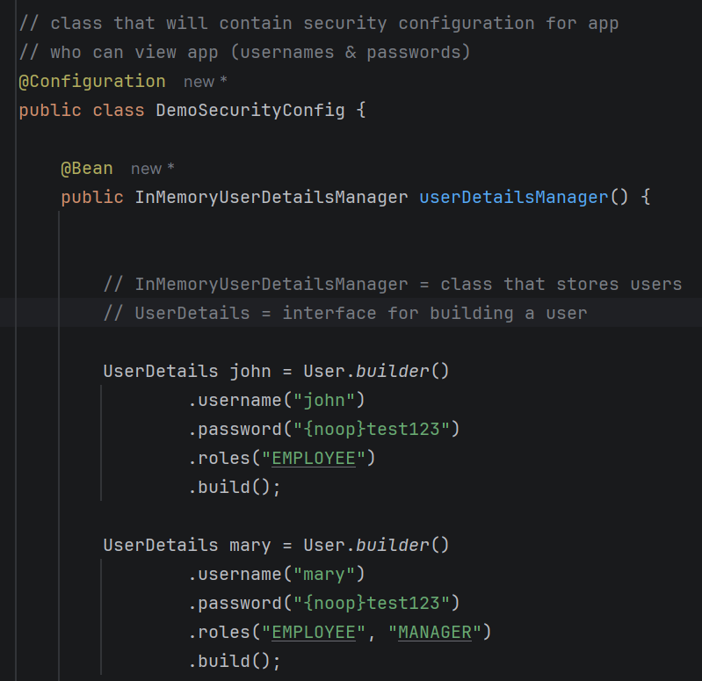
To restrict URLs based on role:
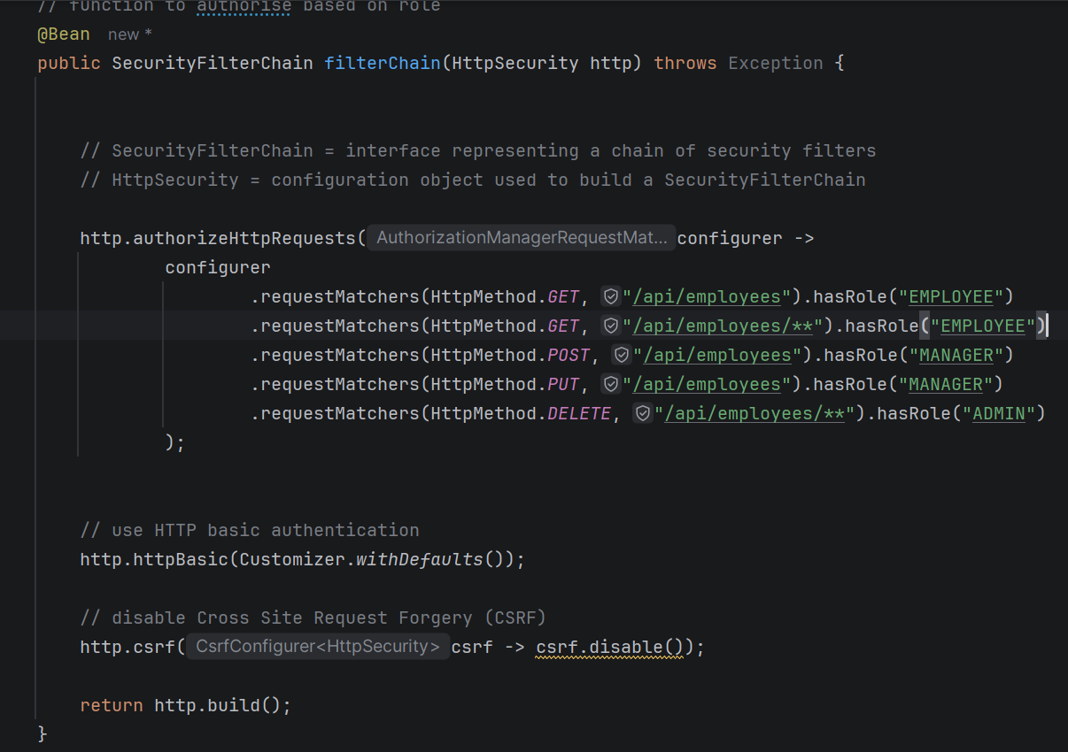

JDBC Authentication: users data from database instead of hardcoded data
- Ensure database connection in application.properties
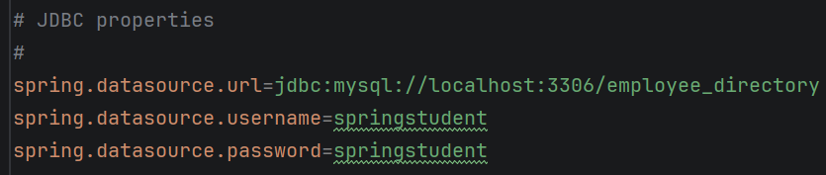
- Add support for JDBC in security configuration file
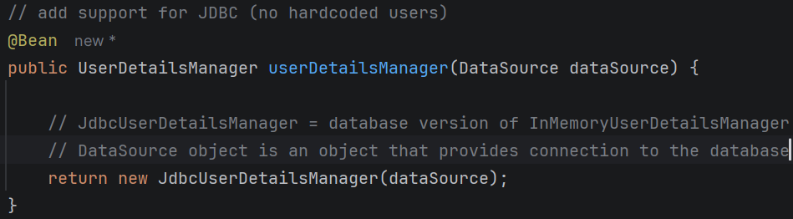

Bcrypt Encryption: encrypting passwords in database using the Bcrypt algorithm
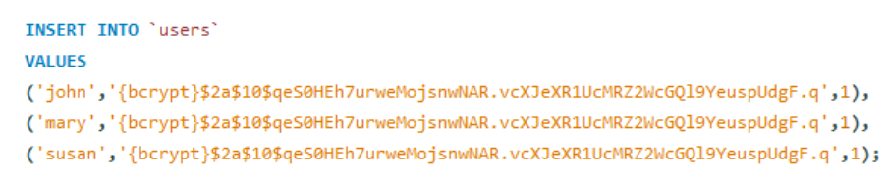

Custom Tables: use custom tables name instead of authorities and users
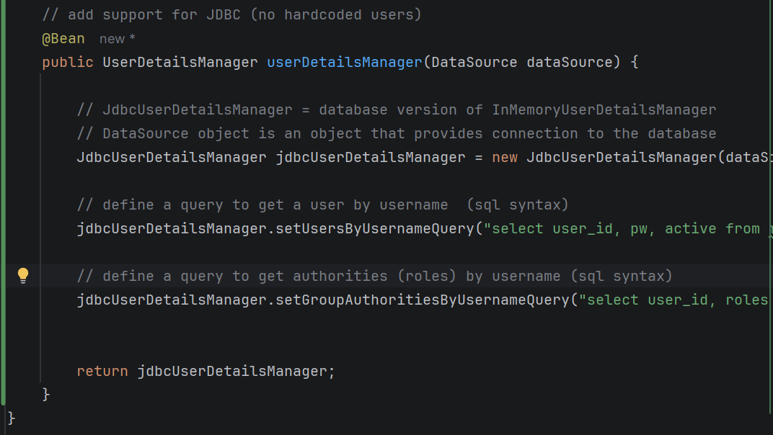

10.8.2026

